Directions:
These directions will explain how to upload your files to our website.
You might want to print this guide out for easy reference.

You can ignore all this if all you want to do is download the files we have made for you.

During this procedure, you will be prompted for a password that you will need to receive from us: Compass Print and Copy Service
10926 Suite I Leopard St.
Corpus Christi, TX 78410
(361) 248-4571
print@compass2797.com

Note: In Microsoft Word you must press the control key on your keyboard and right click on your mouse to open the blue hyperlinks.

Step 1. Download and Install the FileZilla_3.5.3_win32-setup.exe program by pressing the control key on your keyboard and clicking here

You also go back to your browser to get the file (where you downloaded these directions such as Safari, Internet Explorer, Firefox, Google Chrome, etc).

This guide assumes you are using Microsoft Windows; if you are not, please download the respective FileZilla file at their website here

Step 2. Run & Install FileZilla_3.5.3_win32-setup.exe

Step 3a. Download the “Compass_Customer_Login_Information.zip” file (where you downloaded FileZilla).
Step 3b. You can skip this by entering the information manually into FileZilla if you wish:
Host: ftp.compass2797.com
Username: customers@compass2797.com
Port: 21

Step 4. Unzip the file. You can simply open it and drag and drop it to your desktop or any directory your wish.
If you need it, we have provided Winrar for Windows to unzip the file.

Step 5. Import the file you just unzipped titled “Ftp customers@compass2797.com.xml” into FileZilla:
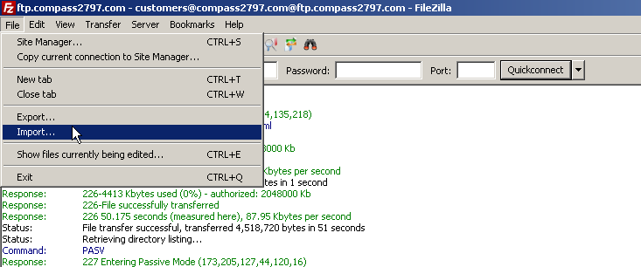
Step 6. Connect to the ftp account “ftp.compasss2797.com”:
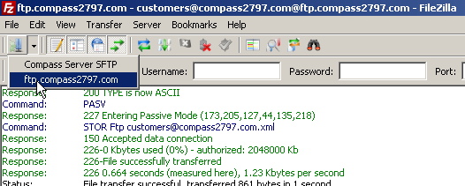
Step 6a. You can drag & drop files into the directory. (FileZilla will then upload the file(s) to our website automatically.)
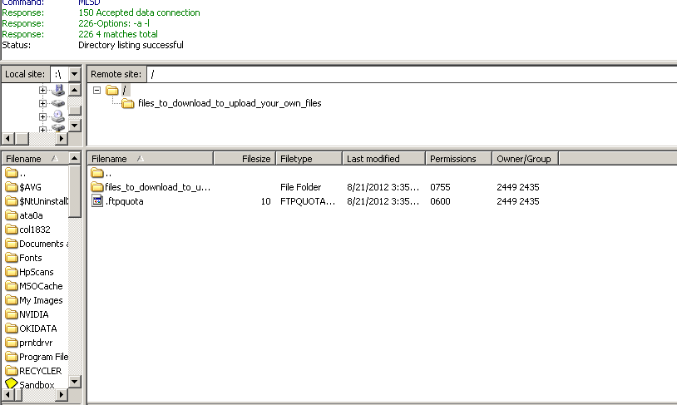
Drag Files to this Location
Step 6b. You can alternately manually upload a file by going to “transfer” on the title bar and select “manual transfer”
Or simply press control+m

Step 8. It is a good idea to call us afterward so we know you uploaded something to us. (361) 248-4571

